GITHUB LINKL : https://github.com/HETKUMAR2510/Back-and-development/upload/

BACK-END DEVELOPMENT FOR ST ALPHONSUS PRIMARY SCHOOL DATABASE SYSTEM

Table of Contents
Assessment 1 3
Part 1: Create an ER Diagram 3
Part 2: Implement a database using PHP/SQL 3
Assessment Task 2 5
Part 1: Report 5
System Design and Functionality 5
Technical Implementation 8
Technology Justification and Benefits 10
Reference List 11

Assessment 1

Part 1: Create an ER Diagram
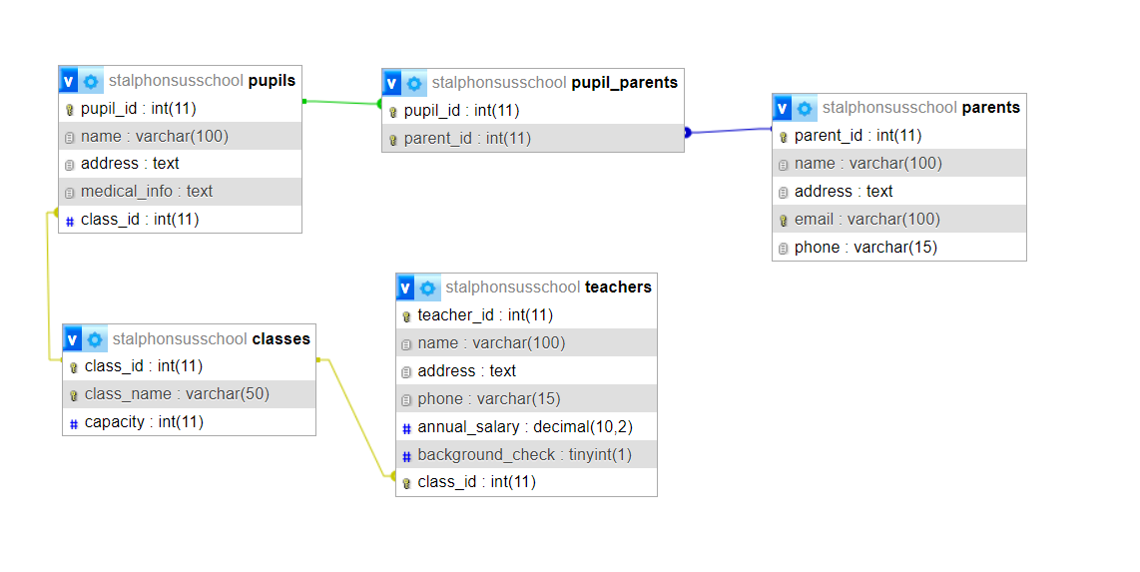
Figure 1: ERD
(Source: made by self using PHPMyAdmin)

Part 2: Implement a database using PHP/SQL
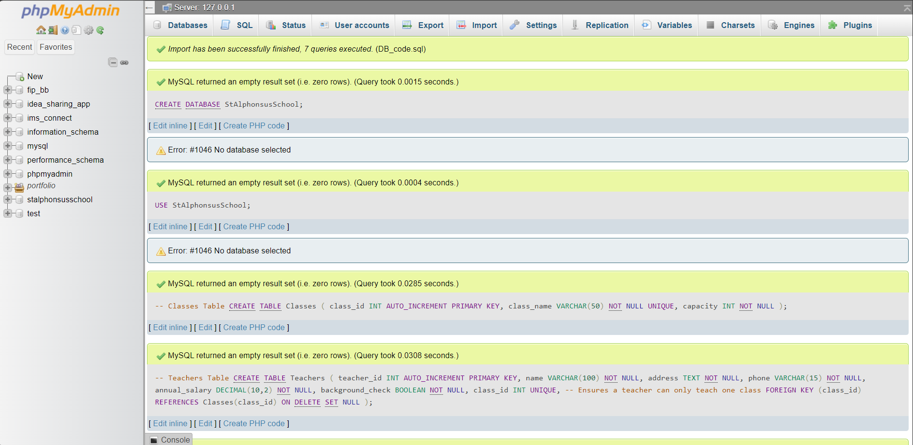
Figure 2: Database Implementation
(Source: made by self using PHPMyAdmin)
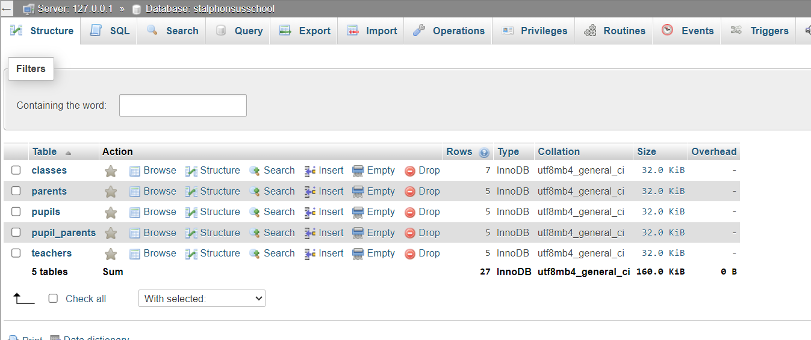
Figure 3: Created Tables
(Source: made by self using PHPMyAdmin)

Assessment Task 2

Part 1: Report

System Design and Functionality
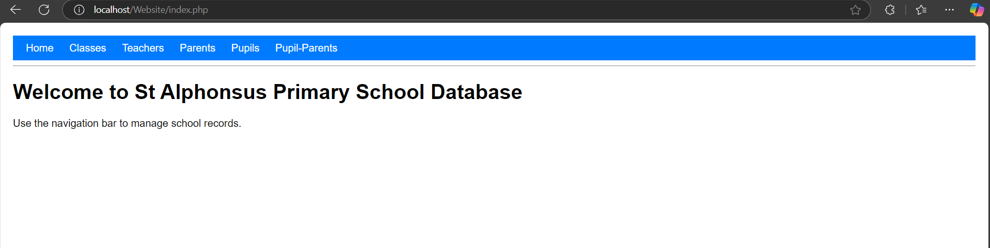
Figure 1: Home page
(Source: made by self using XAMPP)
The web application saves time and effort in managing dates since the website is well-designed to offer school administrators adequate options. At the top, there is a navigation bar providing an opportunity to make a transition between the sections: classes, pupils, teachers, and parents (Wu, 2022). Every section has a grid view of records obtained from the database, as well as a form used to create new records. This design helps the users to be able to view, edit, and add data from the different tables using the same environment without having to log into a different interface.
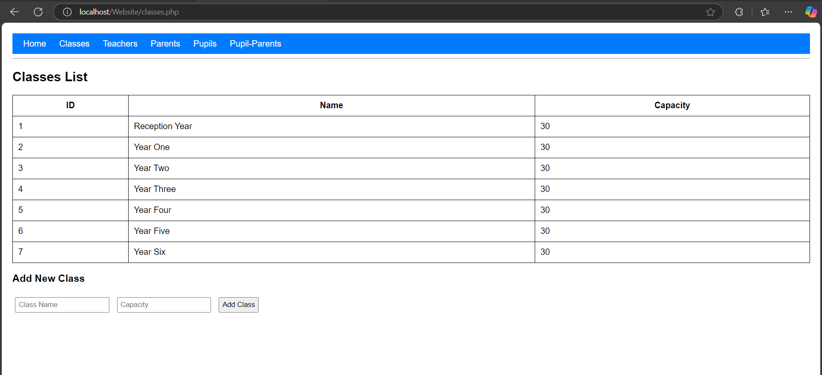
Figure 2: Classes data page
(Source: made by self using XAMPP)

This is a section of the program that is responsible for recording all the classes in the school, their capacities, and their respective teachers.
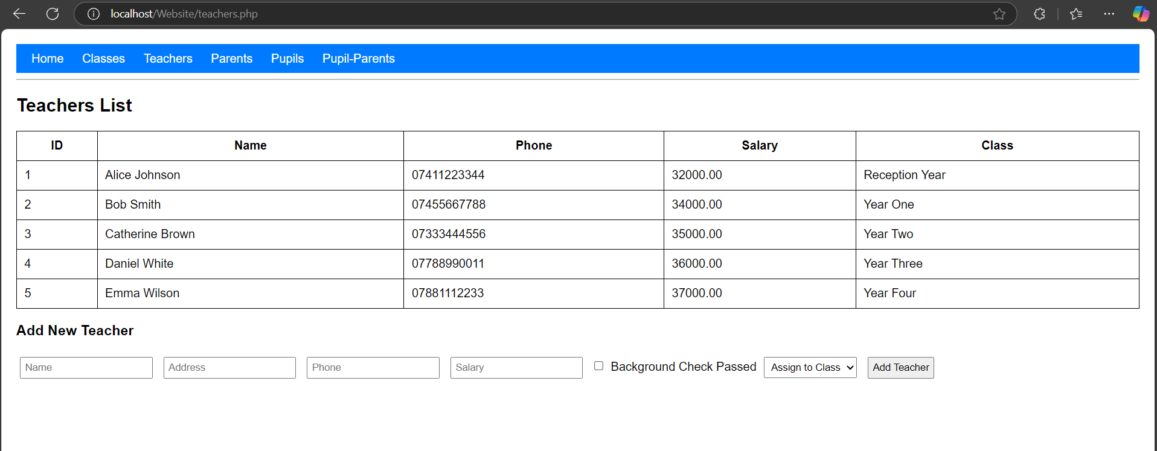
Figure 3: Teachers' Data page
(Source: made by self using XAMPP)
Here, the field of work can only be one class. The teacher also maintains plausible error checking since the teacher can only be allocated one class.
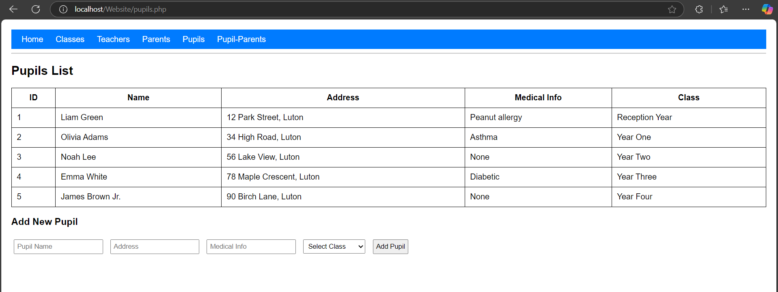
Figure 4: Pupils Data page
(Source: made by self using XAMPP)
The pupil section deals with records of the students regarding their particulars, medical history, and class allotment (Balcita and Palaoag, 2020). An important connection with the class is established to maintain the structured link between the pupils and the academic abilities of each student contained in the course.
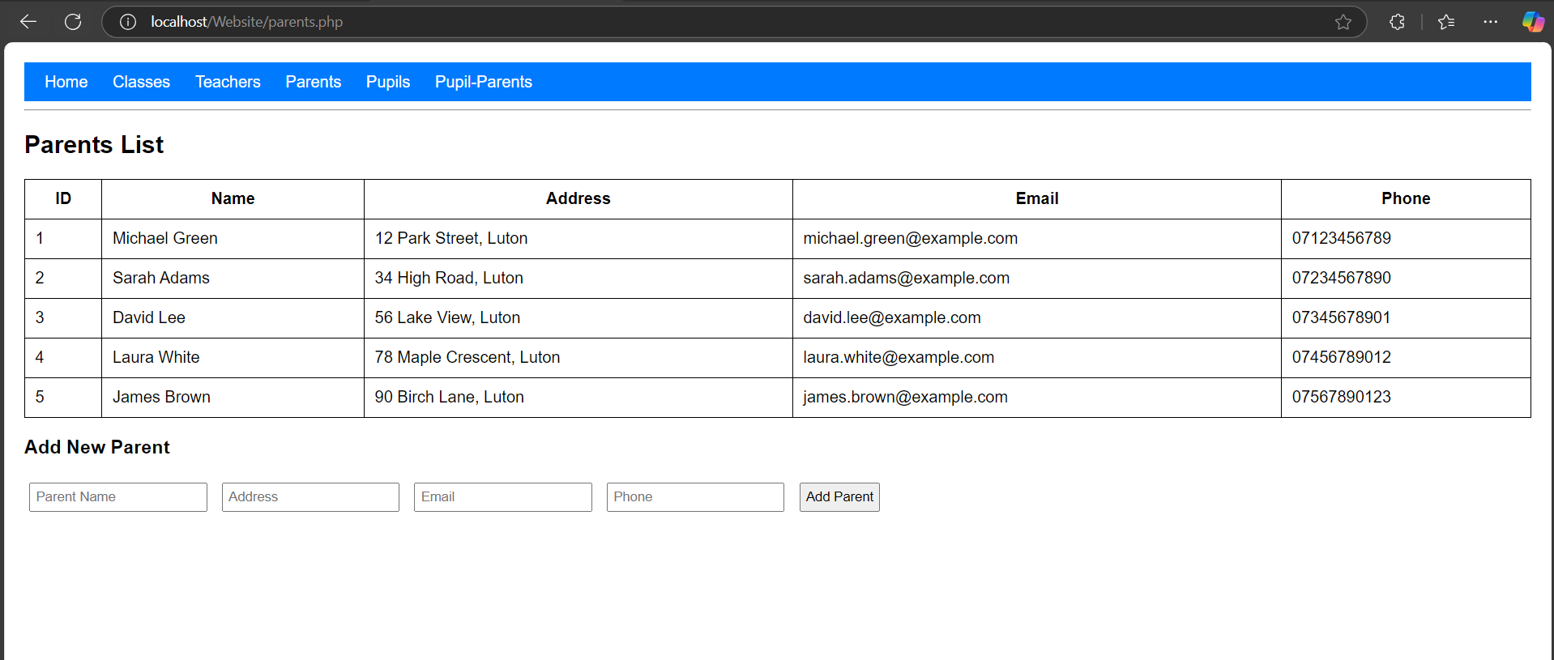
Figure 5: Parents' data page
(Source: made by self using XAMPP)
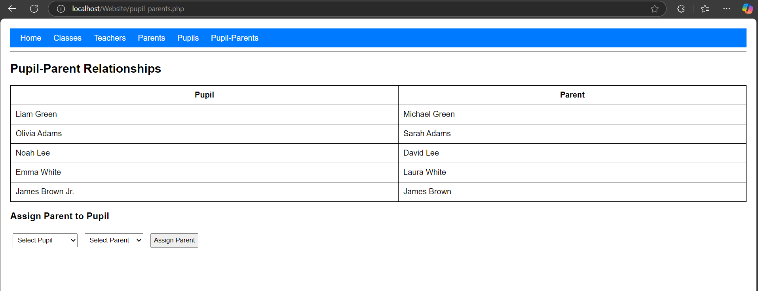
Figure 6: Pupil-Parent Relation page
(Source: made by self using XAMPP)
The parents section enables the administrators to register the parents /guardians of the pupils and a relationship table ensures that a parent can have many children in the school in case one has several children enrolled in that school.
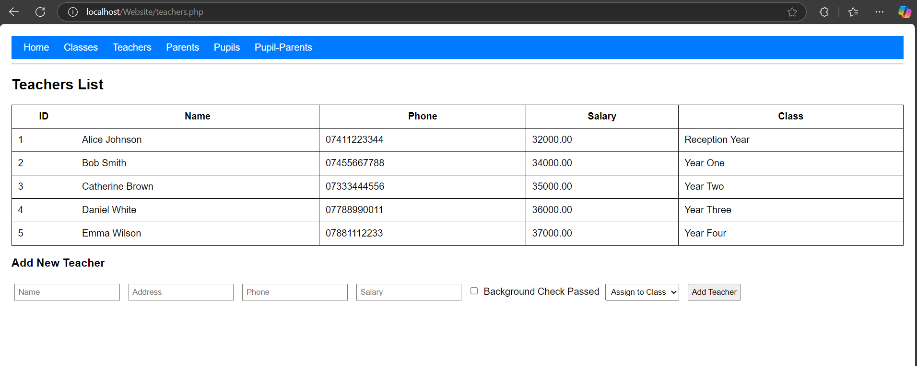
Figure 7: Teachers' data page
(Source: made by self using XAMPP)
The last table, namely the faculty information, holds data about teachers concerning the assigned class and contact information. Such relational connections make it easy to manage records within the database as well as check for and maintain the integrity of the records.

Technical Implementation

The application is developed in PHP and MySQL. SQL is the tool used for querying the database. In the present MySQL database, foreign key relationships have been established that help eliminate and prevent illogical analyses.
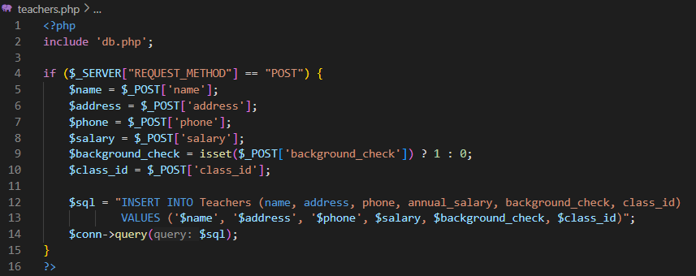
Figure 8: Backend logic
(Source: made by self-using VS Code)
Managing form submission, the PHP backend application uses the $_POST method to capture inputs from the users and then processes the entry before storing it in the database to avoid compromised data from hackers.
Figure 9: SQL Queries in PHP
(Source: made by self-using VS Code)
Prepared statements of SQL are considered in order to prevent SQL injection which helps in increasing the security of the system. It also has validation checks for instance, the fields that are supposed to contain information cannot be left blank, and the validity of an email address and the length of input data is also checked in this system.
Like any other traditional query, dynamic queries are used to retrieve data from the database and display them in HTML tables so that the web pages can automatically update themselves at the time of entering new data (Wahyudi et al. 2022). The use of relational queries, especially the SQL join statements, enables the system to search for data with reasons because of being able to relate to pupils, parents, classes, and teachers. The website is well formatted where every created form has a PHP code that will check the validity of the input data, then perform the SQL query accordingly then the user will be redirected to the proper page.
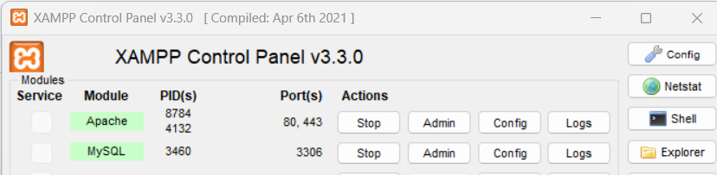
Figure 10: XAMPP control panel
(Source: made by self using XAMPP)
The web app was designed through the XAMPP package in a local host environment that comprises the Apache server and MySQL database. Here, it was necessary to set up the MySQL database employing the phpMyAdmin, create PHP scripts for communicating with the database, and host the application in the htdocs folder of XAMPP. Apache and MySQL services were started to provide local server hosting and database access to make the system easy to develop as well as test. While in the development, various test cases were performed to ensure the validity of records inserted into the database, the records retrieved in the database as well as the relationship between records. This involved using various debugging procedures like the use of var_dump() in PHP to solve any issues that had been made in the implementation.

Technology Justification and Benefits
The back end was programmed in PHP since it supports MySQL, easy to use, and is supported by most PHP hosts. Being an open source, one of the undeniable advantages of PHP is cost efficiency for the development of dynamic web applications and the usage of a set of options for working with forms and relational databases is built into the language (GeeksforGeeks, 2020). It is compatible with MySQL as a natural solution since it provides easy management of data that are required for Web-based systems that involve frequent interaction with the databases. Choosing MySQL against competitors like Oracle or Microsoft SQL Server was made because of its stability with high speed and the fact that it is the MySQL open-source system. It has a good relational database foundation in indexing, foreign key constraint, as well as, query optimization, all of which work efficiently without imposing unnecessarily high costs to the system.
HTML and CSS mean website layout and easy to navigate, Bootstrap makes it have a nice looking and responsive interface. These technologies eliminate the cluttering of the website layout so that any administrator who is managing school records will be easily navigated the website (Light, 2020). This makes all the records stored in the system as being related logically and thus minimizes the redundancy of the records. This meets the result in more sophisticated requirements including users registration and login, various levels of access permissions and automatically generated reports which can be integrated into the system in the future as the need arises.

Reference List
Websites
GeeksforGeeks (2020). Benefits of using PHP in Web Development. [online] GeeksforGeeks. Available at: https://www.geeksforgeeks.org/benefits-of-using-php-in-web-development/
[Accessed 10 Apr. 2025].
Roznovsky, A. (2019). Why Use PHP? Main Advantages and Disadvantages. [online] Light-it.net. Available at: https://light-it.net/blog/why-use-php-main-advantages-and-disadvantages/
[Accessed 10 Apr. 2025].
‌
journals
Balcita, R.E. and Palaoag, T.D. (2020). Building a Framework for the Integration of School Management Systems (BFISMS). International Journal of Information and Education Technology, 10(6), pp.455–459. doi:https://doi.org/10.18178/ijiet.2020.10.6.1406.

‌ Balcita, R.E. and Palaoag, T.D. (2020a). Integration of School Management Systems Using a Centralized Database (ISMSCD). International Journal of Information and Education Technology, [online] 10(9), pp.704–708. doi:https://doi.org/10.18178/ijiet.2020.10.9.1446.

Wahyudi, J., Asbari, M., Sasono, I., Pramono, T. and Novitasari, D., 2022. Database management in MySQL. Edumaspul-J. Pendidik, 6(2), pp.2413-2417.

Wu, D., 2022. The application and management system of scientific research projects based on PHP and MySQL. Journal of Interconnection Networks, 22(Supp02), p.2143043.

